Pie chart showing the breakdown of user types
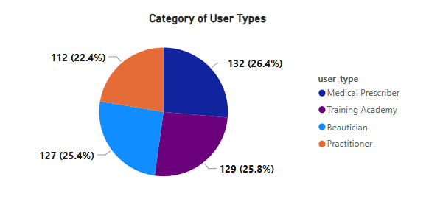

Line graph showing user activity over time (daily logins, session duration);

Faces App Active Regions:
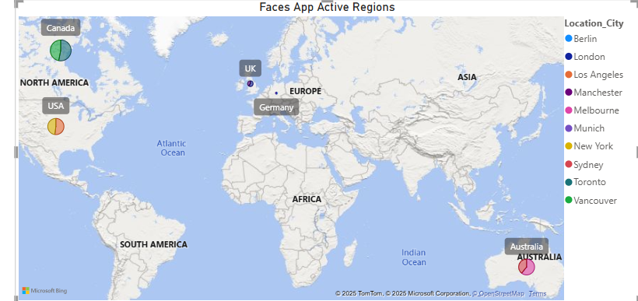

Faces App Active Regions are Canada, USA and Australia.

